Paddle game

This game is an abstract retro game in which the player must stop the ball landing on their side of the play area by bouncing it to the other player’s side. It can be played against another player or against a bot. Players also have powerups which can be used at any time, restricted only by a short cooldown. I made this game way back in 2019 in high school as my major project for my HSC multimedia class.

It was my first shot at making an original game. Up until this point I had learned javascript by remaking old games like pong, breakout and snake. (Maybe have this and corresponding gifs in a smaller side content bar)

1Gameplay from "Paddle Game." A player is playing against the bot.

To make this, I solely utilized the HTML5 canvas element with JavaScript. This means I programmed everything myself, I didn’t even import any existing libraries. I wrote all this code in Notepad++ since it was the only “IDE” I was aware of at the time. I was set on doing every little bit myself so I even made all the (admittedly simple) graphics in MS Paint and the (even simpler) sound effects 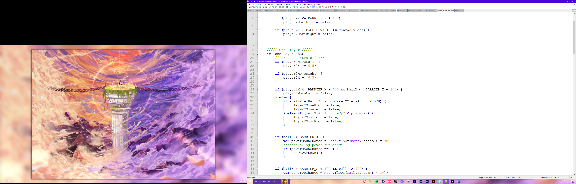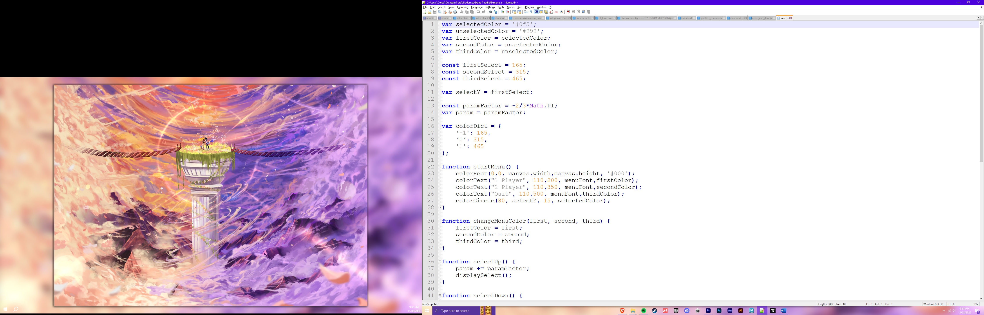in FL Studio.

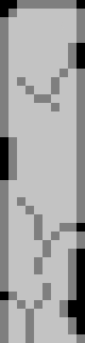I didn’t narrow my focus on any particular skill or aspect of game development while I made this game unlike my recent projects. I had never made a game that was wholly my own so getting to the finish line was all I wanted. I may have even taken the “wholly my own’ aspect a little too far, rejecting existing code libraries, 2d sprites and sound effects but I had a lot of fun figuring out how to do those things myself so I’m glad it was the path I chose. The code could do with a lot of optimising and cleaning up. I can tell I didn’t know how powerful function arguments and returns were and I relied heavily on if-statements, but I don’t think I’ll ever change it. Keeping it this way, I have a snapshot of my programming ability from when I was just starting and when I look back on it, I feel pretty proud of how far I’ve come.

The game only uses three sprites. Everything else is just a solid colour shape or text.

You can play the game in-browser and even download the source code here.